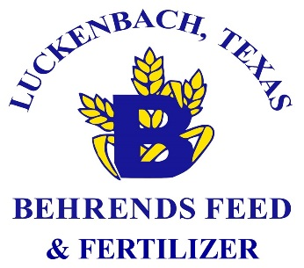
2019 Application
Behrends Feed Livestock Awards Program for FFA and 4-H Exhibitors
Mail form to: Behrends Feed & Fertilizer, 3599 Ranch Rd 1376, Fredericksburg, TX 78624
(830) 997-3410
www.behrendsfeed.net

Name________________________________________________________________________________
Date__________________________________ Social Security #_________________________________
FFA or 4-H Club Chapter________________________ Award Won_______________________________
Type of Animal________________________________ Grand Champion Overall
Show Location________________________________ Reserve Champion Overall
Name of Show________________________________ Breed Champion Reserve Champion
Date of Show_________________________________ Days on Feed _____________________________
Please provide winning Photograph and Photographers Information:
Photographers Name/Phone_________________________________ Image #______________________
Behrends Feed Product (s) Used
_______________________________________________________________________________________
_______________________________________________________________________________________
Address (UPS Address, do not use PO Box) __________________________________________________
City________________________ State______________________Zip_____________________________
Phone _____________________________________
Signature of FFA/4-H Club Leader _________________________________________________________
Signature of Behrends Feed Dealer_________________________________________________________
Name of Behrends Feed Dealer____________________________________________________________
Address_________________________________ City___________________ State_____ Zip__________
Release- Behrends Feed and Fertilizer and its business units has my permission to use the information and statements provided on this form or any part of it, together with my name and address, for all advertising and any other sales promotion purposes, or other media now known or later developed. Unless the minor consent is completed below, I represent that I am over 18 years of age and have the right to enter into this consent release. It is understood my permission to use such will not be reassigned by Behrends Feed & Fertilizer and its business units to anyone else without my express permission. Behrends Feed & Fertilizer feeds for swine, beef, sheep and goats, turkeys and/or broiler products were the primary feeds utilized in my show animals. Behrends Feed & Fertilizer has no financial commitment or obligation as a result of this agreement.
Signature of Applicant__________________________________________________ Date_____________
Minor Consent: I am the Father/mother/legal guardian of the above named subject and give permission for his/her image to be used:
Signature of Parent/Legal Guardian__________________________________________Date___________
PLEASE PRINT NAME________________________________________________________
Witness________________________________________________________________Date___________
Gold Award- Grand Champion, Reserve Grand or Breed Champion at any Major Show or Grand Champion or Reserve Grand Champion at a District Show
Personalized Jacket
Adult Sizes: XS S M L XL XXL 3XL 4XL
Youth Sizes: XS(2-4) S(6-8) M(10-12) L(14-16) XL(18-20)
Silver Award- Grand Champion or Reserve Grand Champion at a County Show; Reserve Breed Champion at any Major Show; or Breed Champion at a District Show
Personalized Pullover
Adult Sizes: XS S M L XL XXL 3XL 4XL
Youth Sizes: XS(2-4) S(6-8) M(10-12) L(14-16) XL(18-20)

Please send a picture of you with your winning animal with this application

